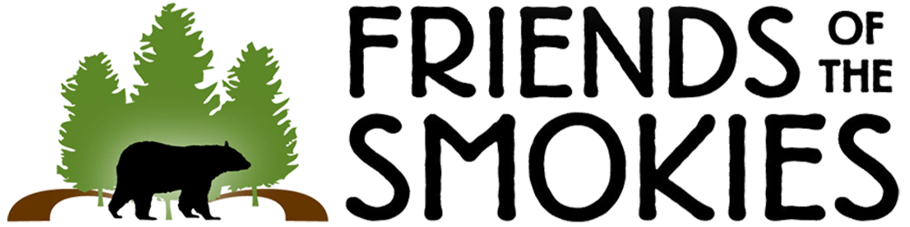

A Gift in Your Honor

In the spirit of the holidays, a gift has been given
to Friends of the Smokies in honor of:

From:

This contribution enables Friends of the Smokies to help assist the National Park Service in preserving and protecting the Great Smoky Mountains National Park.

